A NEW LOOK FOR 2016 GIVES CARSTAR A COMPETITIVE, PROFESSIONAL EDGE

LEAWOOD, KS (January 13, 2016) – At CARSTAR Auto Body Repair Experts locations across the country, bright red and gray paint is being rolled on the walls, new signs are being hoisted, new waiting rooms and customer service areas are being completed – all as part of CARSTAR’s national store rebranding program to give store owners a professional look and competitive edge in their marketplace.

The new store design, which plays off of the red, silver, black and white of CARSTAR’s logo, provides customers a clean, fresh, confidence-inspiring environment from the moment they arrive. It also helps deliver against consumers’ changing expectations for retail automotive services. No longer are they satisfied with a dingy counter area and limited availability of services while they wait for their vehicle. Today, they expect a comfortable waiting area with a host of amenities, meeting spaces where they can review their repairs with a CARSTAR repair professional, a consistent, branded exterior and more.

“We set out on this program to provide CARSTAR store owners a road map for improving their locations,” said Dan Young, president, CARSTAR U.S. “We understand it takes planning, budgeting and man-hours to make these kinds of renovations, all while running a collision repair facility. We’re proud of the leadership our store owners have taken in updating their facilities, and excited to see all the completed locations. Our stores now reflect the work we do – delivering the industry’s highest-quality collision repair and excellent customer service.”

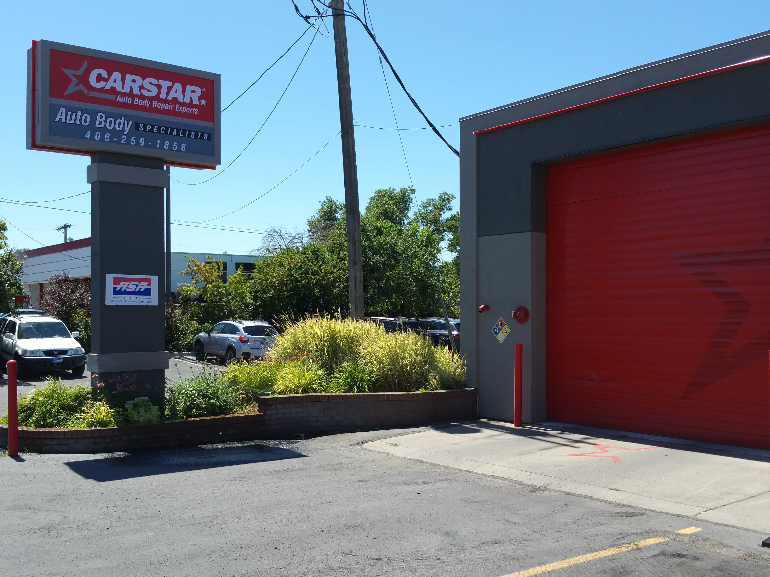
Located in Billings, Montana, CARSTAR Auto Body Specialists has been in business since 1973 and a CARSTAR store since 2005. When CARSTAR Auto Body Specialists manager, Jan Combs, learned in 2013 that CARSTAR franchisees would be rebranding their stores, she said she understood.

“Creating a new look is the natural progression of what businesses need to do to keep their buildings looking fresh, new and nice,” she said. “I was glad to get rid of the old colors. I thought they were dated. We get busy in our day to day lives and overlook that things need spruced up and cleaned up.
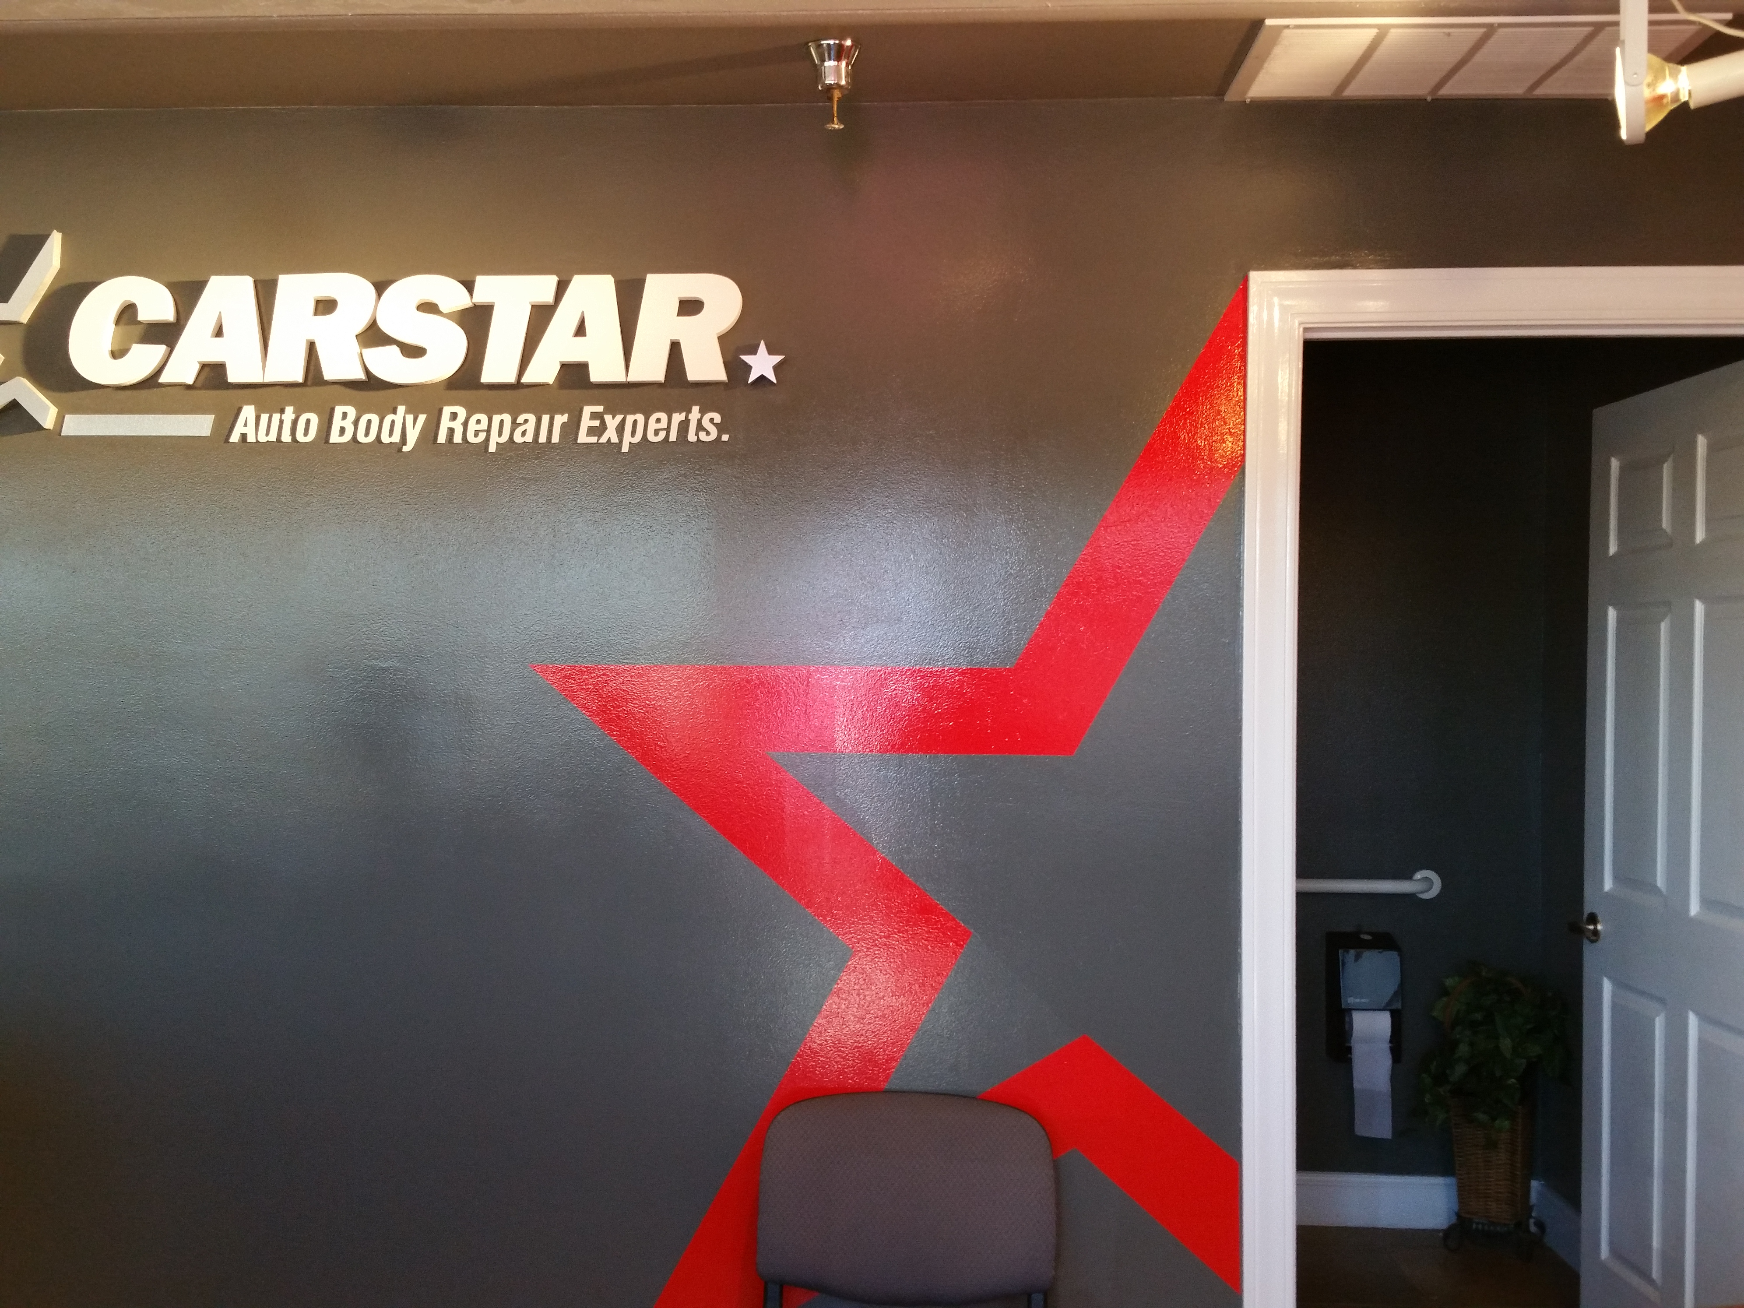
“Initially, the colors seemed mechanical and industrial but when they’re on the walls, customers and employees are really responsive to them. I like the simplicity of the elements. It’s simple and streamlined--and I like that look,” she added. “Before, our store was laid back and rustic. The new branding was a real switch from warm and cozy to professional. And, we look very professional now. The new CARSTAR branding and image has increased business. It brings your name to the forefront. “The customers really noticed the change. Everything looks fresh, and change is good. We used a high-gloss paint for our red focal wall and it makes a very big statement. People notice the difference. It’s like ‘Wow!’”
When Moe Shaban, general manager at CARSTAR Premier in Houston, heard about the new branding initiative, he also was enthused.
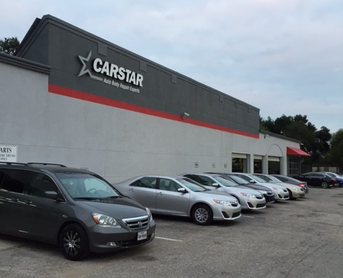
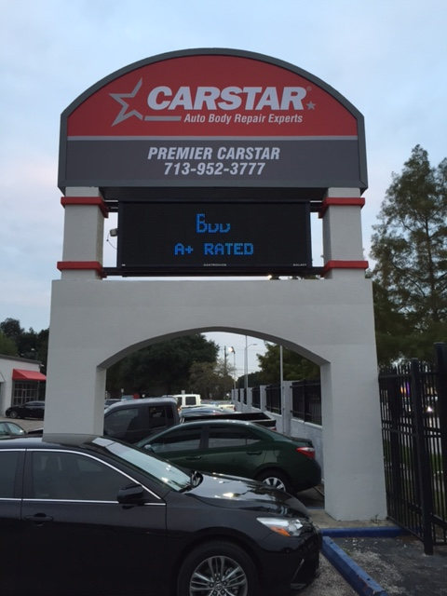

“I was all for it. I like the idea of rebranding. I like it because it’s a new look for the office,” he noted. “If Corporate didn’t initiate the rebranding, things wouldn’t get updated. I liked the idea. I like the newer, modern look and colors. Customers also comment the office looks clean and modern. Customer satisfaction and business have improved since the new branding. The process was smooth and took just 10 months from start to finish.”

Darrin McCaughey, general manager at CARSTAR Don & Ron’s in Omaha, had less than positive thoughts about the new imaging but quickly changed his opinion as the process got underway. Brothers Don and Ron Krzemien started in the body shop business in 1965, and have been a CARSTAR store since 1994. Darrin has been with them since 2005.
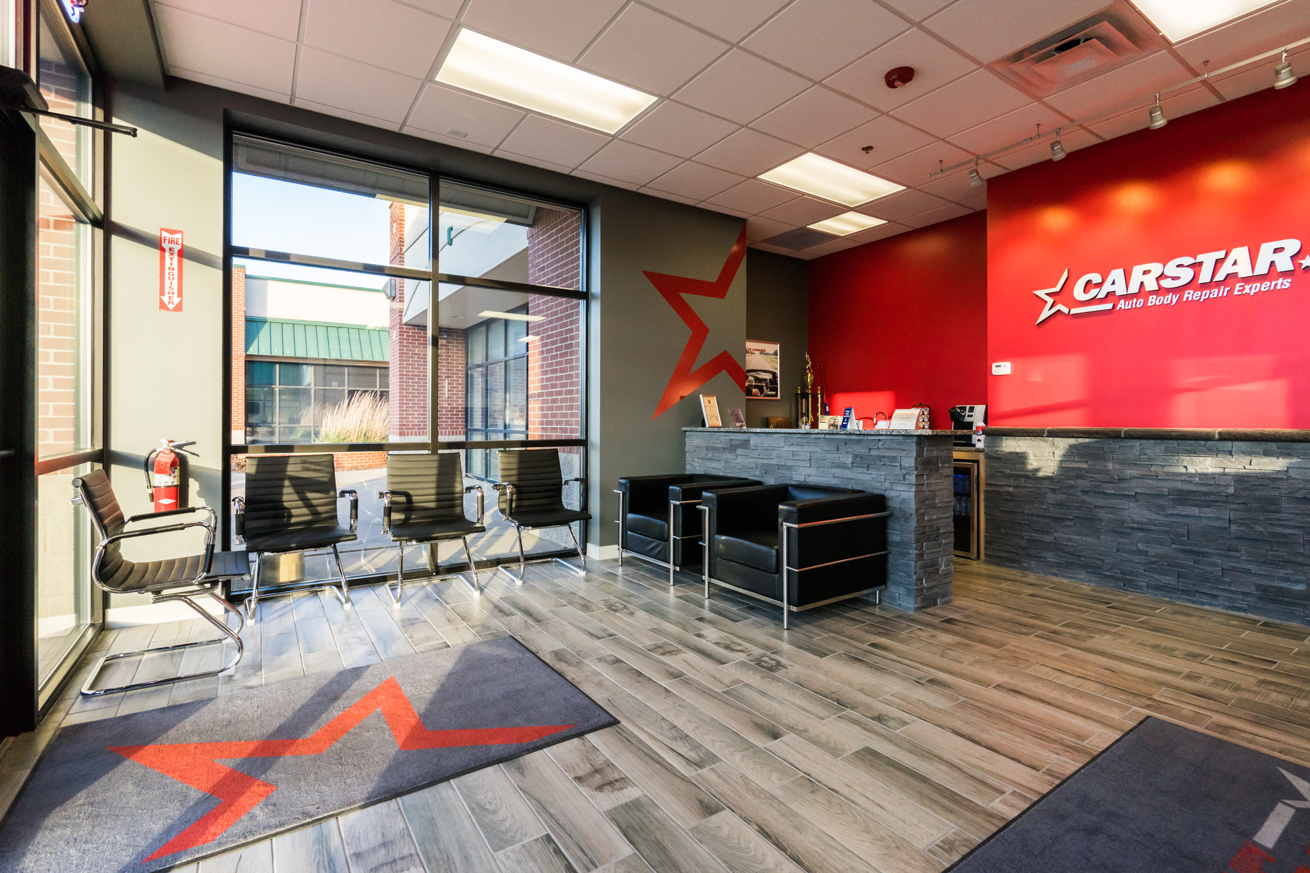
“It’s not like the old days when you walked into a little room and got a hand-written estimate,” McCaughey observed. “If you don’t give your customers professionalism up front, they’ll wonder if you have it in the back. Pleasing the customer is the first point of our business and this new image is part of that. I was not really happy initially, but I felt the brand needed to be updated--and Corporate did a great job on the colors. And, we were fortunate because we’ve been steadily growing for five years and were in the process of needing to expand. It was a double-edged sword that actually worked out great in both aspects.
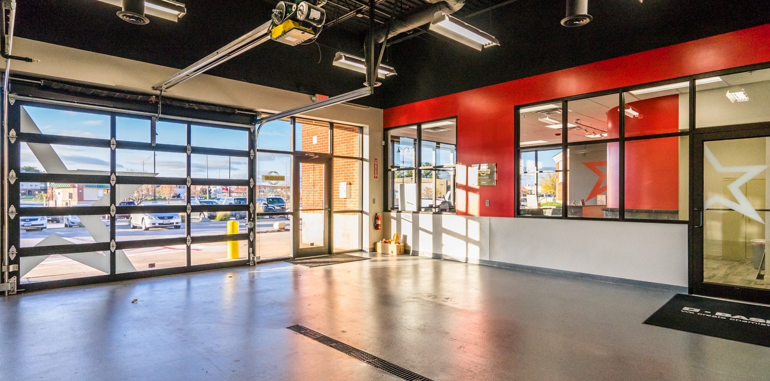
“Ron’s daughter, Christi, and I did most of the planning for the new branding. We started the process in November 2014 and were finished in September 2015,” he said. “It was a pretty smooth transition. We get a lot of comments from our customers. In this day and age, you have to look the part, if you want to be a leader in business. We look very professional now.”

When Dave Jacobus, owner of CARSTAR Jacobus in Vancouver, Washington, learned about the new branding, he also had some negative feelings at the outset.
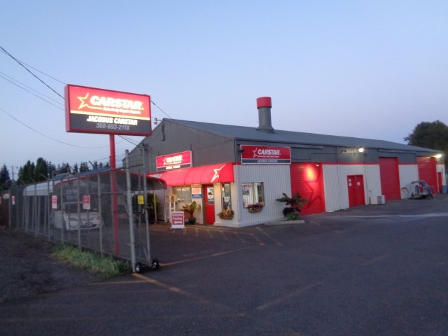
“I was a little upset initially. Not wanting to spend the money--all the change, money and work going into it. But, I learned change is good. We did most of the work ourselves and went local for signage,” Jacobus said. “We’ve been in business 39 years and the carpet hadn’t been replaced for 25. The new look was a great improvement and a great feeling. Amazing, really. I’m very glad Corporate did make me change because it made over our business. The place was so cluttered and too busy. It’s a lot more streamlined now. Everything is judged first by how it looks -- and it transfers to how you do business.”

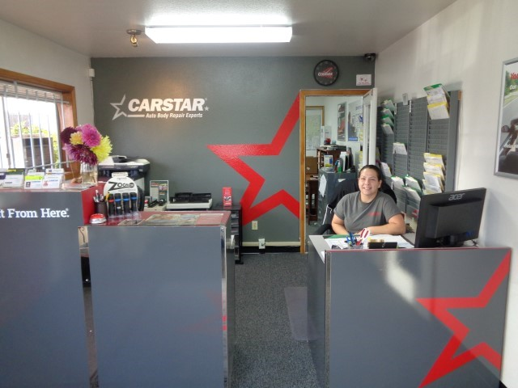
For the team at Jacobus CARSTAR, new imaging took a month from start to finish.

“The technicians were negative about the changes,” Jacobus noted. “But, they sure liked it when the changes were done. Change--a business makeover--is hard for anyone.

“And, the customers? Oh, my gosh,” Jacobus exclaimed. “It’s unbelievable! People say, ‘Wow, your shop looks good!’ It’s affected so many people. We’re a lot more professional looking. Two other businesses, a mile down the road, rebranded after we finished ours. We planted a seed for others. They saw a difference in CARSTAR Jacobus and wanted to do the same thing.”

About CARSTAR

CARSTAR Auto Body Repair Experts--a part of the Driven Brands, Inc. family of automotive aftermarket franchise brands -- is North America’s largest Multi-Shop Operator Network of independently owned collision repair facilities with more than 450 locations in 30 states and 10 Canadian provinces. CARSTAR delivers national scale, consistently high-quality vehicle repairs, repeatable outcomes and the industry’s highest customer satisfaction ratings; all repairs are backed by a national warranty and service guarantee. It was ranked 106th on Franchise Times® annual Top 200™ ranking of the largest franchise systems in North America and was named 18th on the Kansas City Business Journal’s Top 150 Private Companies list. The Romans Group LLC ranked CARSTAR the No. 1 largest MSO in North America. For more information visit www.carstar.comand follow us on Facebook and twitter .

###

Deborah Robinson
President
Victory Management Group PR
312.505.4336
drobinson@vmg1.com

