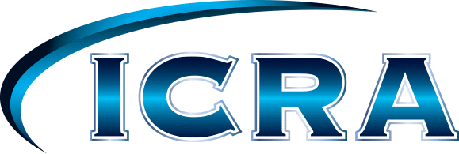 For Immediate Release
Please Contact Janet Chaney
Cell: 480-720-2565
Email: jchaney.cavecreek@gmail.com

Schedule Complete For 7th Annual Midwest Auto Body Trade Show

The 7th Annual Midwest Auto Body Trade Show, February 3rd and 4th welcomes the Collision Repair Industry Education Foundation Student Education Day Friday. The mission of this foundation is to :“Support collision repair educational programs, schools, and students to create qualified, entry-level employees and connect them with an array of career opportunities.” The Midwest Auto Body Trade Show is honored to host the Foundation and students and looks forward to meeting the future of our industry.
Friday’s education series brings a panel discussion that will visit the critical importance of OE Recommended Repair Procedures; is shop certification right for you?; are you doing proper repairs? and are you getting paid for it? The next Friday class is ‘Blue Printing ‘ by Sherwin-Williams Lee Rush. Saturday mornings break out sessions are designed to reach all segments of the industry. “There Is No Free Lunch” brings ICRA lobbyist Scott Weiser and Senator Brad Zaun back to report on Iowa’s legislative business. Noted industry journalist, John Yoswick, brings ‘A Journalist’s Perspective,’ and Lee Rush will “Pave Your Way To A Profitable Future.” Over 70 vendor booths will fill the trade show floor. The Community College Hood Refinish Contest will be judged at 3:00 p.m. Saturday. There will be door prizes, product demonstrations, new car models, ‘Training In The Round’ on the show room floor AND MORE!
Friday, February 3rd
Collision Repair Education Foundation Student Education Day
- 1:00 – 2:30 “OE Repair Recommendations, Certifications, Proper Equipment”
    - “What Is Right For You”
  - Lou DiLisio will moderate a panel of industry experts coming to Iowa.
- 2:30 – 5:30 Lee Rush “Blue Printing -Better Cycle Time -More Profitable Estimates”
- 6:00 - 9:00 Welcome Reception – In The Trade Show
  - Enjoy Your Industry
      - Hors-d’oeuvres~no-host bar
Saturday, February 4th
- 8:00 - 9:00 Greg Borst “Nitrogen Plastic Welding Update”
- 9:00 – 11:30 Scott Schuerman I-CAR “Aluminum Exterior Panel and Replacement”
- 8:00 – 9:30 Mark Claypool Social Media “Grow Your Business the 21st Century Way”
- 9: 45 - 11:30 Tom McGee “What The Collision Industry Needs To Know”
- 11:30 - 1:30 “There Is No Free Lunch” – price is $50.00
    - Meet Iowa Legislators - Learn what ICRA is doing at the Capital
    - Meet Noted Industry Journalist John Yoswick
      - “A journalist’s perspective”
    - Lee Rush “Pave Your Way To A Profitable Future”
- 1:30- 7:00 MIDWEST AUTO BODY TRADE SHOW
  - 70 Display booths
    - Product demonstrations
    - Show Specials
    - Virtual Painting
    - Door Prizes
    - Community College Refinish Contest
    - New Car Models
    - Training In The Round

“There Is No Free Lunch” is $50.00 per person. The rest of this great industry event is being provided "No Charge" thanks to the sponsors and vendors that support the Midwest collision industry. Please sign up online at www.iowacra.com. For additional information, please contact Janet Chaney at 480-720-2565.

XXX

