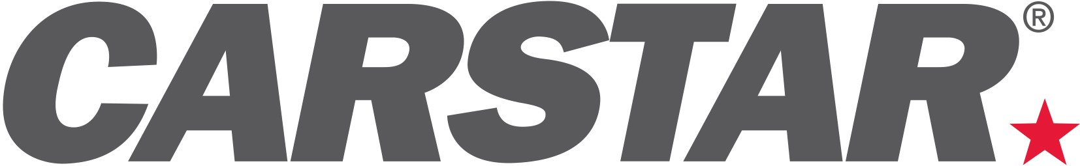

CARSTAR NORTH AMERICA kicks off 2018 following year of record performance

CHARLOTTE (January 18, 2018) -- As CARSTAR North America kicks off 2018, it marks a year of continued performance improvements and growth across the network. In conjunction with its insurance partners, CARSTAR and its store locations have measured ongoing gains in customer service, operational excellence and brand awareness.

“As CARSTAR enters its second year operating as one network across the U.S. and Canada, we are poised to deliver even more performance improvements and operational efficiencies for our store owners and insurance partners,” said Michael Macaluso, President, CARSTAR North America. “We have been able to continue to streamline our operations, adopt best practices from each and leverage the resources and operational expertise of Driven Brands to enhance our platform for growth in the coming years.”

Key CARSTAR milestones in 2017 include:

- Record revenue across the network of nearly $850 million, which again made CARSTAR the largest MSO in North America
- Continuous growth in same center sales for the last 61 months and improved franchise profitability across the system
- Expansion through new store growth, including opening operations in North Carolina and South Carolina, marking more than 80 new locations in 2017 – with 49 in the U.S. and 31 in Canada – and the 500th store last January
- Industry-leading KPIs including length of rental and NPS scores
- Expansion of Driven Brands' procurement programs with Meineke Car Care Centers for mechanical repairs and 1-800 Radiator and A/C for product sourcing
- Continued growth of cross-border insurance program and CARSTAR Care Center to accommodate insurance carriers and their customers across North America
- Expansion of the CARSTAR insurance program with significant DRP growth across North America, reflected in that some 90 percent of CARSTAR transactions are driven through insurance work

CARSTAR Outlines Strategic Growth Plans for 2018

For this year, CARSTAR and Driven Brands continue to focus on growing the CARSTAR network across the U.S. and Canada, delivering continued operational improvements and providing purchasing efficiencies. Key initiatives include:

- Driving unit growth across the U.S. and Canada through aggressive store development, with a goal of 600 locations by mid-year
- Increasing organic growth at its current locations through the CARSTAR Proprietary EDGE Performance Platform, operating efficiencies and new fleet and insurance programs
- Continuing to execute against performance-based agreements with the major insurance carriers and secure more of these relationships
- Launching a national consumer brand campaign that showcases CARSTAR as the most trusted, premier provider of collision repair services
- Leverage the Driven Brands synergies for efficiency and cost-savings

“This year, we saw a number of our top store owners expand to new locations and grow their businesses, and we welcomed many great new owners to our system,” said Macaluso. “We are confident in the continued strength of the economy and in our business model for delivering success in the year ahead.”

About CARSTAR

CARSTAR North America-- a part of the Driven Brands, Inc. family of automotive aftermarket franchise brands -- is North America’s largest Multi-Shop Operator Network of independently owned collision repair facilities with more than 550 locations in 32 states and 10 Canadian provinces. CARSTAR Auto Body Repair Experts in the U.S. and CARSTAR Collision and Glass Services in Canada deliver national scale, consistently high-quality vehicle repairs, repeatable outcomes and the industry’s highest customer satisfaction ratings; all repairs are backed by a national warranty and service guarantee. CARSTAR was named the No. 1 largest MSO in North America by The Romans Group LLC, named 255 on Entrepreneur magazine’s Franchise 500® list and ranked 106th on Franchise Times® annual Top 200™ listing of the largest franchise systems in North America. For more information visit www.carstar.com and www.carstar.ca and follow us on Facebook and twitter. CARSTAR is actively seeking new franchisees. Interested parties should contact 888.505.6815.

###
Deborah Robinson
President
Victory Management Group PR
312.505.4336
drobinson@vmg1.com

