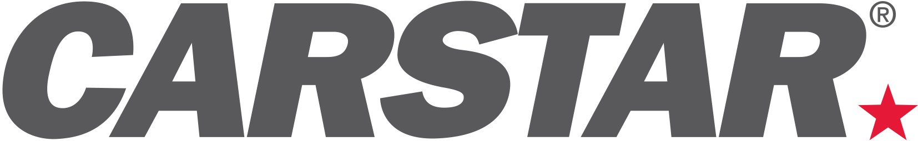

CARSTAR Offers Insurance Outlook for 2018

CHARLOTTE (January 18, 2018) -- While the landscape of the collision repair industry is expected to consistently grow this year, that growth is likely to come from shops who are able to expand their businesses and open new locations, improve their efficiency and build their insurance relationships. That is the focus of the CARSTAR Auto Body Repair Experts U.S. Insurance team this year. Here are the key initiatives:

- Continued Performance Improvement: The biggest challenge lies with the ability to perform as one CARSTAR, delivering the same high-quality repairs and stellar customer service in EVERY CARSTAR repair center. CARSTAR is working to come together to perform as a truly self-managed network, solving for market-based initiatives like load leveling, scheduling and work segmentation while keeping what is best for the customer top of mind. Programs like the CARSTAR Operating Procedures and the EDGE Performance Platform help drive these consistently high standards.
- Increasing Performance-Based Agreements: The repeatable, high performance standards drive the ability to secure additional performance-based agreements. These relationships, in which carriers and collision repair companies have mutual interest in strong performance, will continue to grow.
- Expanded Estimatics Review Team: As online estimating becomes a critical tool in delivering accurate repair orders, CARSTAR is expanding its estimatics review team. This improves the efficiency of the overall repair process, reduces cycle time and enhances customer satisfaction.
- Self Management: As insurers continue to experience cost pressure, many are reducing field claims staff, assigning less resources to manage MSO relationships and relying on MSO’s to “self manage” their operations. This approach works well for a high performing system like CARSTAR and in many cases can expedite the repair process.
- Specific Store Level Insurance Plans: Not only will relationships with national and regional carriers continue to require a national insurance support team, one point of contact and streamlined procedures, there is also an opportunity to tailor programs to the stores’ needs and the market demands. This will be an area for growth in 2018.
- OEM Certifications: OEMs are also investing heavily in technology, lining almost every inch of their vehicles with sensors and cameras which feed mountains of data to super computers and accident avoidance systems, all paving the way for the self-driving car. All this technology in cars today is driving vehicle complexity and challenging the industry to keep up with OEM innovation. This makes OEM certification programs a focal point for OEMs, Insurers and repairers and ultimately all of the customers.

“We’ve spent the last few years building a strong national platform with our insurance partners, and that work will deliver ongoing benefits for CARSTAR store owners, the carriers and ultimately, their consumer customers,” said Arlo Johnson, VP of Insurance Relations, CARSTAR Auto Body Repair Experts. “Our stores continue to improve their process and performance and that drives our national standards as the industry’s most-trusted, highest-quality repair partner.”

About CARSTAR

CARSTAR North America-- a part of the Driven Brands, Inc. family of automotive aftermarket franchise brands -- is North America’s largest Multi-Shop Operator Network of independently owned collision repair facilities with more than 550 locations in 32 states and 10 Canadian provinces. CARSTAR Auto Body Repair Experts in the U.S. and CARSTAR Collision and Glass Services in Canada deliver national scale, consistently high-quality vehicle repairs, repeatable outcomes and the industry’s highest customer satisfaction ratings; all repairs are backed by a national warranty and service guarantee. CARSTAR was named the No. 1 largest MSO in North America by The Romans Group LLC, named 255 on Entrepreneur magazine’s Franchise 500® list and ranked 106th on Franchise Times® annual Top 200™ listing of the largest franchise systems in North America. For more information visit www.carstar.com and www.carstar.ca and follow us on Facebook and twitter. CARSTAR is actively seeking new franchisees. Interested parties should contact 888.505.6815.

###
Deborah Robinson
President
Victory Management Group PR
312.505.4336
drobinson@vmg1.com

