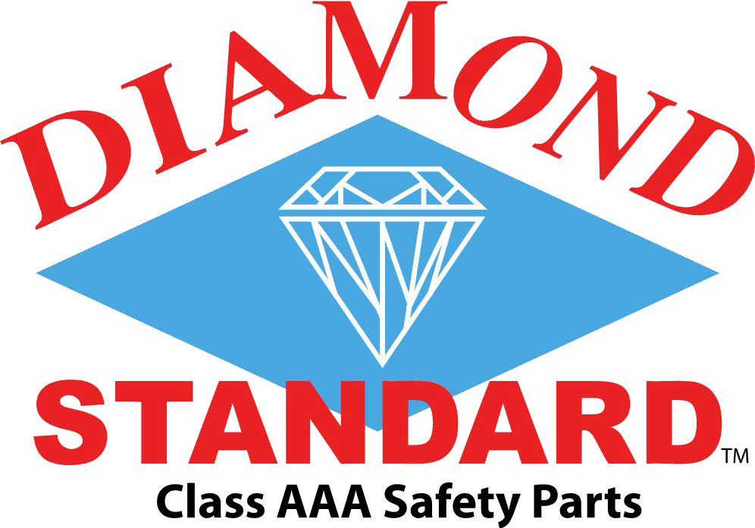
Press Release
March 8, 2018

Diamond Standard 40 MPH IIHS Moderate Overlap Test
On February 21, 2018, MGA Design Research Corporation of Burlington, Wisconsin, performed a 40 MPH moderate overlap test to strict IIHS Protocol on a 2009 Honda Fit with a Diamond Standard CAPA Certified reinforcement bar.
The results of the Diamond Standard reinforcement installed on a 2009 Honda Fit with 81,704 miles compared to IIHS 2009 Honda Fit test on a new vehicle tested on October 2, 2008 is graphed below.

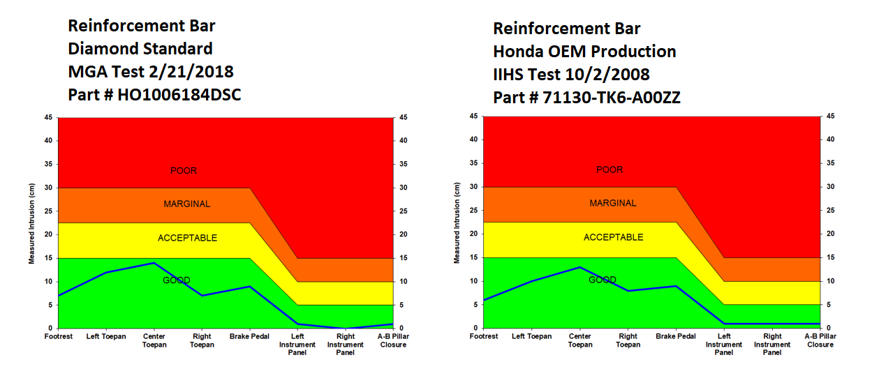
Of Note:
MGA Research Corporation purchased the vehicle / Set up the testing to IIHS Protocol
Diamond Standard Reinforcement Bar installed by a local ICAR Technician at MGA’s Request
Test was witnessed in person by a current ICAR Board Member

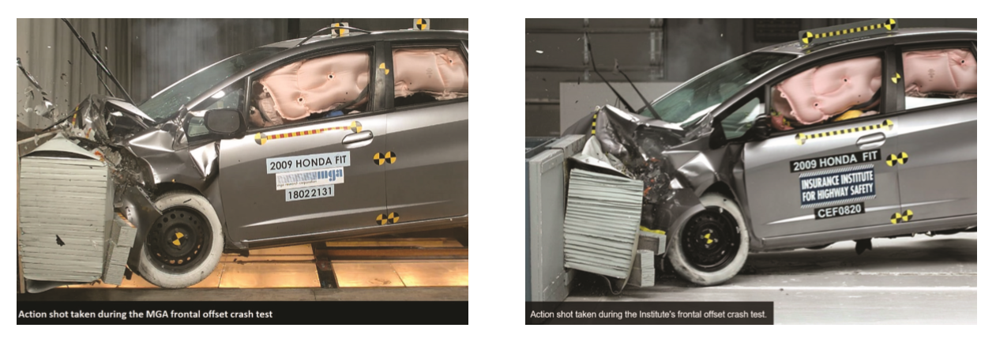
MGA tested 20 different reinforcement/absorber components of OEM and Diamond Standard in Quasi Static and multiple speed Dynamic Sled tests prior to the IIHS protocol test for Diamond Standard.
“Here causality was isolated in a true scientific test protocol. Component testing for Diamond Standard was designed by the late Jim Hackney, Former NHTSA Director of Crashworthiness and Father of the 5 Star Crash Rating System still in use worldwide to this day” said Michael O’Neal, President of Diamond Standard.
“As a final note, one couldn’t help but notice the toughness of a 10 year old Honda Fit in a violent 40 mph test.”

