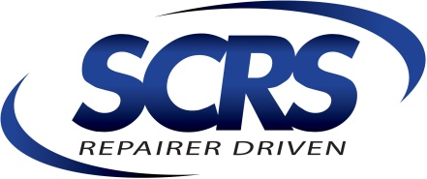
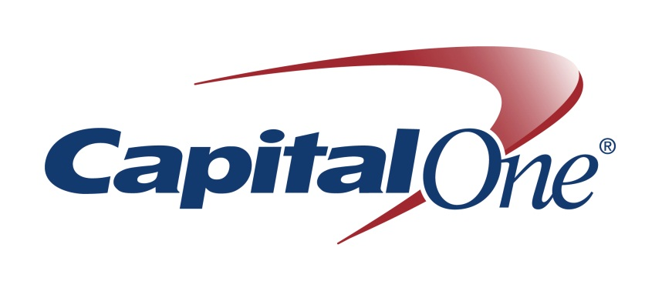
Media Release

Contact: Casey Werderman, 804-316-5878
casey.werderman@capitalone.com

Capital One Spark Business Partners with the Society of Collision Repair Specialists to Empower Businesses in the Automotive Repair Industry

Automotive Design Legend Chip Foose will Join Capital One Spark Business at SEMA 2016

McLean, Virginia (October 17, 2016) –Capital One Spark Business today announced a new partnership with The Society of Collision Repair Specialists (SCRS) and plans to host automotive legend Chip Foose at the 2016 SEMA Show, the world’s premier automotive trade event.
“We’re passionate about helping small businesses succeed, and see a real opportunity for business owners in the automotive repair industry to benefit from our industry leading suite of Spark Business credit cards that offer industry leading rewards and benefits. With unlimited 2% cash back on every purchase, you could be putting thousands of dollars back into your business each year,” said Buck Stinson, head of small business credit card at Capital One. “SCRS is a natural partner that we align with on delivering tools and resources that accelerate business growth. We’re thrilled to work with SCRS and Mr. Foose to support and empower business owners in the automotive space.”
Capital One Spark Business will host a series of activities at SEMA that will provide small businesses with the tools and insights they need to drive their business forward. They include:
- A conversation in partnership with SCRS titled “A Business Fueled by Passion – Talking Shop with Chip Foose” on Tuesday, Nov. 1 from 3:00 – 5:00pm in the North Hall Upper Level, Room N258. During the session, legendary automotive designer and entrepreneur Chip Foose will talk about growing a business, finding and leveraging resources to drive success, and lessons he learned along the way. Chip will be joined onstage by Buck Stinson, head of small business credit card at Capital One. The panel will be live-streamed via Periscope – follow @CapitalOne on Periscope to learn from Chip first-hand about creative ways to maximize business potential and to accelerate growth.
- Custom car sketch by Chip Foose inspired by attendees’ ideas on what drives automotive repair businesses. The sketch will take place at the Capital One Spark Business booth (Booth #30318) on Wednesday, Nov. 2 at 10:30am. Printed copies of the sketch will be available for Foose to sign on Friday, Nov. 4, from 9:00am – 9:30am.

“Starting a business in the automotive world is tough and having it succeed is even harder.” said Chip Foose, owner of Foose Design. “I know first-hand how dedicated Capital One is to helping small businesses succeed, and look forward to partnering with them on a number of exciting events at SEMA.”
As part of Capital One Spark Business’ new role as a corporate member with SCRS it will sponsor their Repairer Driven Education (RDE) Series at SEMA this year.
“We are very excited for Capital One Spark Business to join as a corporate member of SCRS and to partner with them on a number of incredible events during SEMA,” said Aaron Schulenburg, Executive Director of SCRS. “The financial expertise, insights and products that they bring to the table is a great benefit for SCRS members, and opens the doors for unique collaboration to benefit the industry. We are thrilled that they have also sponsored our Repairer Driven education series at the show, and proud to have such recognizable and respected brands as a part of the education platform we deliver.”
###
About Spark Business
Capital One® offers a broad spectrum of financial products and services to consumers, small businesses, and commercial clients. Spark Business from Capital One comprises a suite of innovative products and services specifically designed for small business, including credit cards with unlimited rewards, no-fee checking and savings, and secure and flexible merchant service offerings. Spark Business provides tips, resources, and inspiration to help your business thrive at www.SparkBusinessIQ.com. For more information, visit www.CapitalOne.com/smallbusiness.
About SCRS
Through its direct members and 40 affiliate associations, SCRS is comprised of 6,000 collision repair businesses and 58,500 specialized professionals who work with consumers and insurance companies to repair collision-damaged vehicles. Additional information about SCRS including other news releases is available at the SCRS website: www.scrs.com. You can e-mail SCRS at the following address: info@scrs.com.
About SCRS' RDE Series:
REPAIRER DRIVEN EDUCATION (RDE) series will feature 4 days of seminar offerings, many of which are uniquely designed and being offered only at the 2016 SEMA Show, including the OEM Collision Repair Technology Summit. Each session has been individually selected or crafted by SCRS because the content focus on information that is relevant to the diverse array of marketplace perspectives within the collision repair industry. Better your business, and register at www.semashow.com/scrs.

