Dematerialization and Democratization in Auto Manufacturing

Around 2 billion cars have been built over the last 115 years; twice that number will be built over the next 35-40 years. The environmental and health impacts will be enormous. Some think the solution is at hand with electric cars or other low or zero emission vehicles. The truth is that if you look at the emissions of a car over its total life, you quickly discover that tailpipe emissions are just the tip of the iceberg. An 85 kWh electric SUV may not have a tailpipe, but it has an enormous impact on our environment and health. A far greater percentage of a car’s total emissions come from the materials and energy required for manufacturing a car—the mining, processing, manufacturing, and disposal of the car itself, not the car’s operation. As leading environmental economist and Vice Chair of the National Academy of Sciences Maureen Cropper notes, “Whether we are talking about a conventional gasoline-powered automobile, an electric vehicle, or a hybrid, most of the damages are actually coming from stages other than just the driving of the vehicle.” If business continues as usual, we stand to increase the total global pollution generated by automobiles by three times or more, as we go from 2 billion to 6 billion vehicles manufactured. The conclusion from this is straightforward: how we make our cars is actually a bigger environmental issue than how we fuel our cars. We need to dematerialize—to dramatically reduce the material and energy required to build cars—and we need to do it now.

These facts are demonstrated in a 2009 report by the National Academy of Science, Hidden Costs of Energy: Unpriced Consequences of Energy Production and Use. That report considers the total human and environmental damage stemming from the various stages of automotive use: the manufacture of the vehicle, the manufacture of the vehicle’s fuel, and the operation of the vehicle. This chart makes clear that tailpipe emissions are only a small part of the total emissions picture:

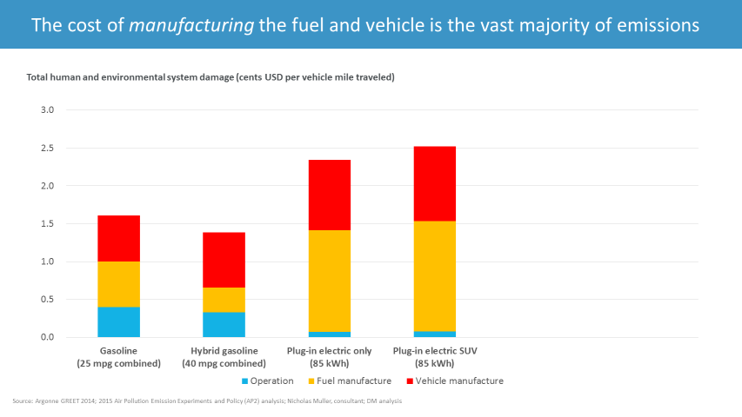

Thus, the prevailing marketing and policy focus on drivetrains (e.g. gasoline vs. electric) has dangerously obscured the debate and drawn our attention from the larger problem: the emissions and other environmental damage stemming from the manufacturing of cars.

We therefore need to focus our innovation not simply on automobile products, but at least as much on the process by which those products are made. Such process innovation needs to accomplish two equally important goals:

- the dramatic dematerialization of our cars, which means reducing material and energy inputs and waste; and
- the democratization of car manufacturing, which means giving small teams a set of affordable tools that enable them to design, build, and scale a wide range of complex vehicle structures.

Dematerialization is the only effective path by which we reduce the environmental damages stemming from automobiles. Dematerialization will lead to far fewer emissions from both manufacturing and operation, much lower material and energy inputs in manufacture, dramatically better gas mileage, lower wear on roads, and fewer fatalities from car accidents.

Yet to dematerialize manufacturing, we first need to democratize it. Traditional auto-makers are held captive by the massive capital investments required to build cars using traditional methods. Every one of today’s car companies, from Toyota to Tesla, has invested hundreds of millions of dollars in every car factory it has built. That means they must organize everything they do around generating a maximum return on that huge fixed cost investment. As industry analyst Horace Dediu observes, “Production is everything. Capacity utilization is the first priority for an auto manufacturer. Capacity is why firms are not allowed to die and entrants are not allowed to enter. If you want to find the Next Big Thing in automobiles, look for a new production system.”

Democratizing car manufacturing requires that small teams have a set of affordable tools that enable them to make cars of their own design. Such a tool set would empower people in car manufacture the same way ARDUINO empowered people in electronics. ARDUINO is a modular platform that hides its complexity behind an interface that is easy to use. It thereby enabled an explosion of hardware and software innovation. Because of ARDUINO, many of the latest tech products—from Kickstarter devices, to the Internet of things, to home automation—have been built not by huge corporations, but by small, nimble teams.

At Divergent Microfactories, we set out to build an industrial-strength ARDUINO for cars—a kind of CARDUINO, so to speak. The key enabling technology we’ve developed is what we call a Node. A Node is a 3D-printed alloy connector that joins aerospace-grade carbon fiber tubing into standardized building objects. This simple tool can enable a small team to design and build car chassis that range from two-seat sports cars to pick-up trucks. Just like with the ARDUINO, the Node hides its underlying complexity behind a simple, easy-to-use interface.

The Node-based chassis solves the bigger problems we set out to address. It drives dematerialization and democratization. A traditional chassis can weigh over 1,000 pounds, whereas we have built a prototype that weighs about 100 (61 pounds of aluminum and 41 pounds of carbon fiber), even as it’s much stronger and more durable. All of the nodes and carbon fiber tubing that make up a car chassis were fit into the backpack in the photo below. The chassis requires dramatically less material and energy to produce.

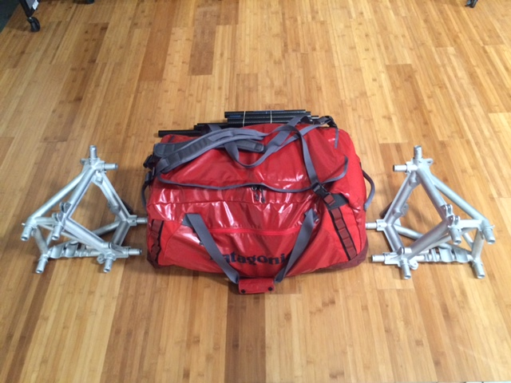

A dematerialized car is a greener, lighter, and safer car that can be made locally. It will have less wear on our roads and fewer fatalities in accidents. A super-lightweight car built with Divergent Microfactories’ new technology generates only a third of the total health and environmental damage of an 85 kWh all electric car. Our objective is drive that down to a quarter or less. And it can be made locally and built to last.

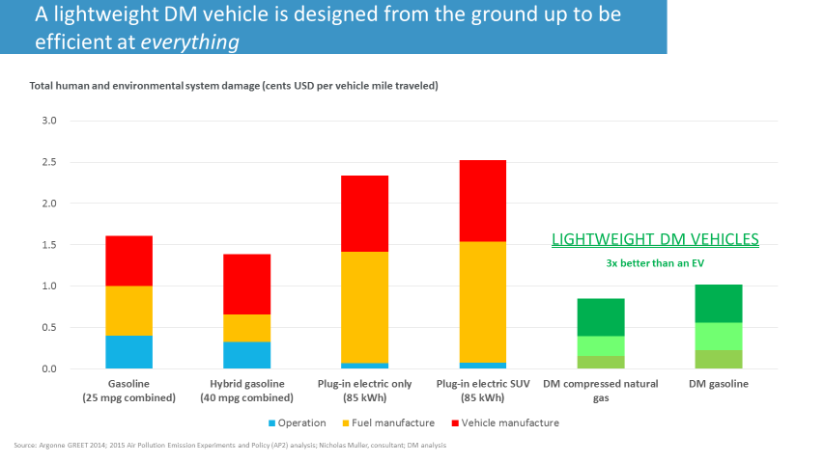

The chassis in this time-lapse video was assembled by hand in under half an hour (it could be assembled in about 15 minutes with a small robotic cell).

[Time Lapse Video]

Whereas a traditional car factory would cost hundreds of millions of dollars, one of our micro-factories would have a startup cost of under 20 million dollars and produce up to 10,000 cars a year. If we centralize Node manufacture, we think it is possible to create microfactories that would cost less than $5 million to set up.

Just as the PC democratized the computer industry and ARDUINO democratized electronics, so our solution will give small teams all over the world the tools to develop and build innovative new car designs that will meet the needs of local communities. Now, because of Divergent Microfactories, you no longer have to be a billionaire to design and build new cars at scale. Imagine hundreds or even thousands of small teams around the world, bringing real innovation back to the car industry for the first time in nearly a hundred years through a network of pioneering teams. These teams would diverge and share, accelerating the pace of innovation, while protecting our environment—and then applying that knowledge to other complex structures.

The only sustainable path forward for the car industry is in dematerialization and the democratized innovation that will drive it. With the introduction of Divergent Microfactories’ tools, we believe that future is now possible.

Here is the first living example of what we can achieve: the world’s first 3D printed supercar. It has one-third the emissions of an electric car, one-fiftieth the factory capital cost, and twice the power-to-weight of a Bugatti Veyron.

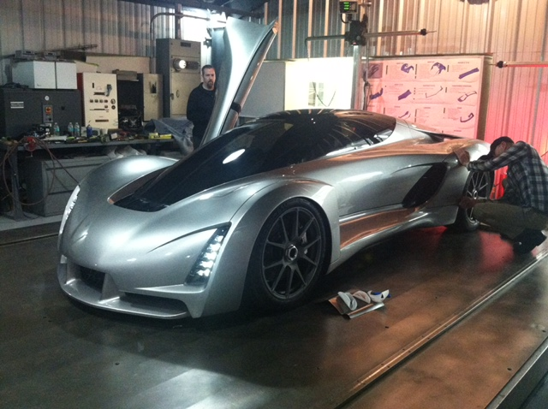

Emmott, Stephen, Ten Billion, p. 95, New York, New York: Random House, Second Edition, 2014.
“Unclean at Any Speed,” Ozzie Zehner, IEEE Spectrum. June 30, 2013. http://spectrum.ieee.org/energy/renewables/unclean-at-any-speed
“The Entrant’s Guide to The Automobile Industry,” Horace Dediu, Asymco. February 23, 2015. http://www.asymco.com/2015/02/23/the-entrants-guide-to-the-automobile-industry

