Contact : Judell Anderson
Alliance of Automotive Service Providers of Minnesota
612-623-1110
judell@aaspmn.org

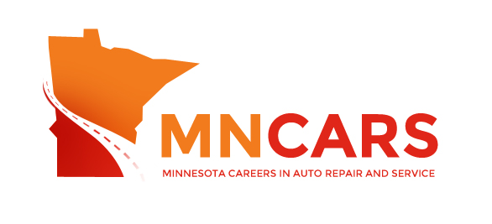

CarCareers.org Now Features a Job Board

MINNEAPOLIS (November 7, 2016) – The Minnesota Careers in Automotive Repair and Service (MNCARS) is pleased to announce the addition of a job board to its website, www.carcareers.org.
The purpose of the new feature is to facilitate connections between industry employers who have job openings with those seeking employment. The site will also reinforce MNCARS’ primary messages – that there is a high demand for employees in the automotive service, parts and collision repair industries, with a multitude of career paths available in a wide variety of employment settings.
Those interested in posting available automotive-related jobs will receive introductory pricing of $25 for a 30-day listing. AASP-MN members receive a $5 discount and should call the AASP-MN office to request the promo code. To post a job, visit https://jobs.carcareers.org/jobs.
Job postings from the Automotive Career Network, which includes the Auto Care Association and Society of Collision Repair Specialists job boards, as well as Indeed postings, will also appear on the job board.
For more information, contact Judell Anderson at 612-623-1110 or judell@aaspmn.org.

About Minnesota Careers in Automotive Repair and Service
Minnesota Careers in Automotive Repair and Service (MNCARS) is a workforce initiative created by a cross-section of automotive industry representatives, including independent repair shops, multiple-shop operators, suppliers, technical college administrators and other industry organizations. Its goal is to ensure a future workforce for Minnesota’s automotive service industry by raising awareness and recruiting people into technical college automotive education programs (collision and mechanical) and industry careers. MNCARS will help parents, influencers and students overcome misperceptions of the industry and attract the qualified employees the industry needs.

###

