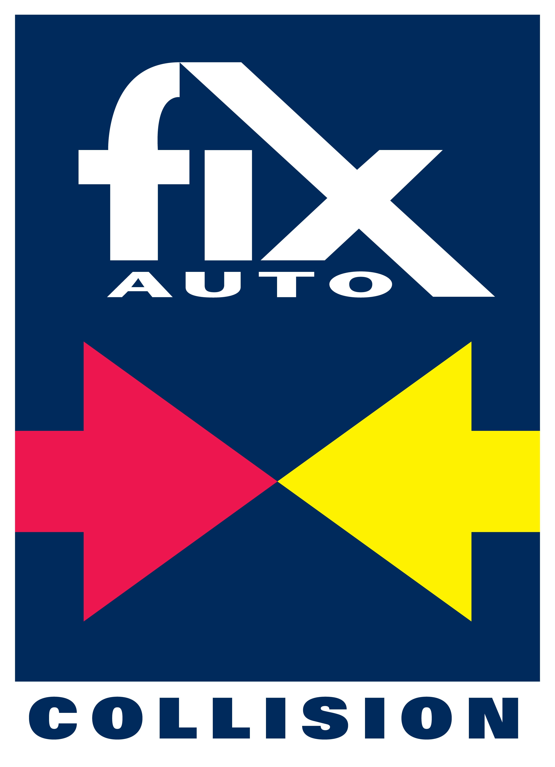

For Immediate Release

June 27, 2017

Contacts: Vince Heald, Beck Ellman Heald (vheald@behmedia.com) - 858-453-9600
Dennis Ellman, Beck Ellman Heald (dme@behmedia.com) - 858-453-9600
Jonathan Herrera, FUSA, Inc. (jherrera@fixauto.com) - 858.764.0756

FIX AUTO USA WILL FIGHT TO RETAIN LICENSING RIGHTS

San Diego, CA – Fix Auto USA has announced that it will assertively and legally fight to retain licensing of the Fix Auto trademark in the United States. This statement responds to an announcement by Mondofix, Inc., which purports to do business as Fix Auto World, which was distributed today.
“We were extremely disappointed to read the Mondofix press release today concerning U.S. operations since it has no basis in fact,” said Erick Bickett, Chairman of Fix Auto USA. “Mondofix has made its intent clear to usurp the hard-earned equity and loyalty we have built in the United States for nearly 20 years. We will vigorously defend and protect our business relationships from any activity that would affect or injure those business relations.”
Paul Gange, Fix Auto USA’s President and CEO added, “We currently have 116 franchisees in the United States. We have grown by over 135% in the past 5 years, and have system wide annual revenue approaching $300 million. Our future growth prospects are stronger than ever based on Fix Auto USA’s existing business model, insurance relationships and industry reputation. The company plans to continue operating and growing the Fix Auto brand in the U.S. for the next decade, and longer.”
The company further stated, “Disregarding contracts and assuming that business relationships may be simply bought and sold in the United States may be the impression of foreign business executives like those at Mondofix. We believe otherwise. We have worked diligently for many years to not only establish our brand and reputation in the market place, but to deliver on the promises we have made. We still value integrity and fair business practices. We will fight to protect our business and the values we have stood on for so many years.”

Fix Auto USA, via our legal counsel, notified Mondofix, the Canadian based company that owns the trademark, that it will continue to operate under the existing License Agreement that exists with Mondofix. Fix Auto USA has also notified Mondofix that it will be held accountable and liable for any damages incurred by Fix Auto USA or its franchisees as a result of Mondofix’s actions involving the existing License Agreement.

###

About Fix Auto: Based in San Diego, California, Fix Auto USA provides a platform which enables independent owner-operated collision repair facilities to achieve success in a consolidating marketplace. Fix Auto members benefit from a trusted brand, multi-level insurance representation, leading edge technology, centrally managed claims processes, and pooled purchasing power, all combined to ensure consistent performance and accelerated growth opportunities. For more information about Fix Auto, go to www.fixautousa.com.
###

