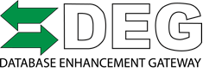
For Immediate Release
For Additional Information Contact:
Danny Gredinberg
admin@degweb.org
(302) 423-0207

Database Enhancement Gateway Recognizes Spanesi Americas for Gold Sponsorship.

Colorado Springs, Colorado 6/13/2018- Database Enhancement Gateway (DEG) introduces new Gold sponsor Spanesi Americas to the 2018 line up.
“We are excited to have a top tier equipment supplier providing measuring, anchoring, and refinishing equipment solutions as a supporter of the DEG. Spanesi® is a true 360º solution by not only providing collision repair equipment, but by also recognizing the value in supporting a resource available to our industry that provides such positive impact on the damage documentation process,” Shared Danny Gredinberg, DEG Administrator.
DEG users have the ability to help fix omitted and inaccurate information found in the estimating programs through inquiries. The database can also be utilized to verify and document necessary operations that have been addressed by other users, and confirmed by the information provider.
Gredinberg added, “As vehicles evolve with new materials and technology, so must the tools and equipment to repair the vehicles. DEG helps end-users gain clarification to both the repair process and the proper documentation of repair plans requiring advance repair methods utilized today.” ​
DEG is funded by member dollars from the Society of Collision Repair Specialist (SCRS) and the Alliance of Automotive Service Providers (AASP) as well as corporate sponsorships from groups such as PPG, Collision Advice, ASA and now Spanesi Americas.
"We have been looking at additional avenues to support organizations that are able to bring a positive and immediate impact to the collision repair industry," explained Timothy W. Morgan, COO and Managing Director of Spanesi Americas. "The DEG provides a much needed service to our industry that bridges the information gap between collision repair facilities and information providers."

The DEG provides collision repair facilities the ability to directly submit information to Information Providers in order to facilitate review of published repair procedure labor times. "The DEG is one of the most under-utilized services available to collision repair facilities and their staff," continued Morgan. "We speak with owners and technicians every day that need this service. We are excited to help bring this organization service to our industry.”

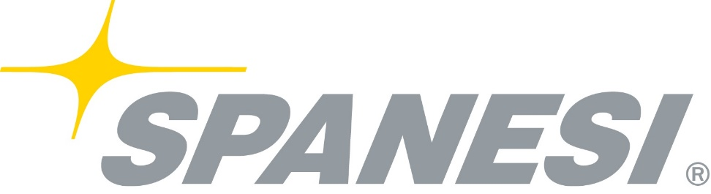

About Spanesi Americas

Spanesi Americas is a company created with the same passion and expertise Spanesi SpA has become known for globally since 1989. Spanesi Americas' mission is to bring new products and technologies to body shops in the Americas to enable technicians to perform repairs to high standard of excellence. Formed in September 2012, as a subsidiary of Spanesi SpA.

Spanesi SpA is the leading international producer of automotive repair equipment and manufacturer of effective body shop solutions. Spanesi's product lines includes the Spanesi 360 Degree Concept for collision repair businesses, including: Straightening Benches, Multibenches, Touch Electronic Measuring Systems, Fixturing Systems, Vacuum Systems, Welding Machines, Infrared Lamps, Lifts, Painting Tools, Spray Booth Equipment.

For more details about Spanesi Americas products and solutions, contact Timothy Morgan, COO and Managing Director. 123 Ambassador Drive, Suite 107, Naperville, Ill., 60540, 1-224- SPANESI (224-772-6374), tmorgan@spanesi-americas.com,www.spanesi.com.
DEG
About the Database Enhancement Gateway (DEG): The DEG is an initiative designed to help improve the information in collision repair estimates through proactive feedback about vehicle-specific errors, omissions and inaccuracies in the database and labor times. With support and funding from the Alliance of Automotive Service Providers (AASP), Society of Collision Repairs (SCRS) and other industry organizations, the DEG can provide its services free of charge to the industry. For more information on the DEG please visit www.degweb.org or email admin@degweb.org .

