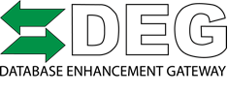
For Immediate Release
For Additional Information Contact:
Danny Gredinberg
admin@degweb.org
(302) 423-0207

2019 March Taylor DEG Challenge
Sponsored by: Toyota Motor North America
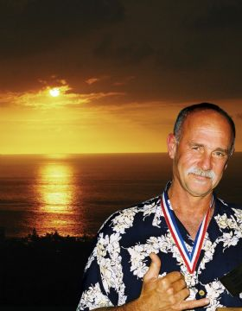

In the month of March 2019, in honor of March Taylor (Original founder of DEG). The DEG is challenging you to submit DEG Inquiries!
Two ways to participate and be entered into our grand prize drawing valued at $480 USD.
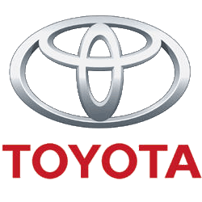
Toyota Motor North America has graciously donated 1 year subscription to Toyota Tech Info Standard Pass.
Raffle and winner will be announced Monday April 1st @ 10am MST
How to play:
Submit a valid database inquiry at www.degweb.org . Every inquiry submitted gives you 1 submission into our grand prize drawing. No Limit on inquiry for raffle tickets. See rules for details on inquiry.
And or Increase your winning chance by:
Donating to the DEG will get entered into the Grand Prize drawing. NO limit on tickets/ donations!
$20 gets 2 tickets
$50 gets 10 tickets
Users can donate thru the DEG Pay Pal Link. Upon receiving a successful inquiry / donation, the user will receive an email with their Raffle ticket(s). DEG Donation page CLICK HERE.
Rules
What is a successful inquiry?
Correct spelling of First and Last Name
Contact information: Phone Number/ Email Address
Inquiry submitted for any of the three IP’s (CCC, Audatex, Mitchell) to help improve the quality and accuracy of collision repair estimate data. Inquiries will need to meet the following guidelines: Omissions, errors, inaccuracies found in the databases. This would include Labor Issues, Parts database issues, vehicle specific inquiries.
Inquiries not meeting the criteria above, will not be eligible for raffle submission, but will still be responded too. If an inquiry is questionable, the DEG Joint operating committee will review for final decision.
What happens if I don’t win the raffle?
We understand there is only 1 winner for the March Taylor Challenge 1 year Toyota Tech Info Subscription. Anyone/ any shop can still sign up for Toyota Tech Info and subscribe to a two day, monthly or 1 year subscription. Just because you didn’t win the prize, should not stop you from using the invaluable information available.
Live Event: The DEG administrator Danny Gredinberg will be at the AASP Northeast Trade Show 3/15-3/17 2019. Please stop by the AASP Booth to learn more about the DEG and participate in the 2019 March Taylor DEG Challenge.

