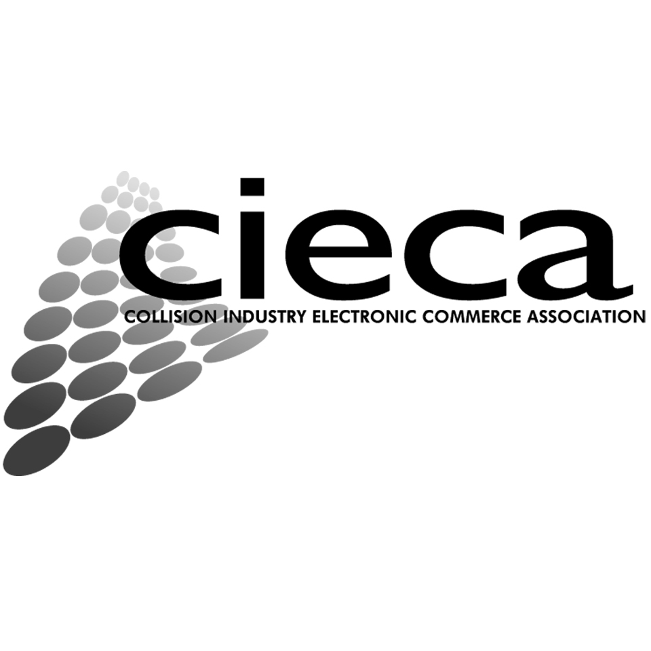
FOR RELEASE ON JUNE 6, 2019 AT 8 AM CST

CIECA ANNOUNCES EXECUTIVE DIRECTOR DEPARTURE

Northbrook, IL—June 6, 2019— CIECA announced today that Fred Iantorno, CIECA’s executive director, has officially resigned from his position effective July 31, 2019.

“We are incredibly appreciative of the contributions that Fred has made to CIECA over the years and he will be truly missed,” said Steve Betley, CIECA’s chairman of the board. “He has made a tremendous impact on CIECA and the industry and we wish him all the best in his future endeavors.”
Iantorno became executive director of CIECA in July 2002. During his leadership, Iantorno helped build over 200 messages and all of the codes needed to provide meaning to those messages. In addition, he was instrumental in the implementation of the messages to improve the operation and bottom-line of CIECA’s member organizations.

“Where I have taken CIECA has been an accomplishment of which I am most proud,” said Iantorno. “It has been in a direction that I felt benefited the entire industry. We are now a financially-viable organization playing key roles in impacting the industry.”

“I want to thank all those who have helped me build CIECA into a successful organization, one that continues to have a great impact on the industry as a whole, with a benefit to all.”

“Having been involved in the original process of bringing Fred to the organization some 17 plus years ago, I would personally like to thank Fred on behalf of our industry for so many great years of leadership,” said Erick Bickett, CIECA’s founder. “He has done a fantastic job leading the CIECA team, which includes the staff and all of the industry volunteers.”

The board of directors will conduct a search to fill the executive director position.

“The CIECA organization was formed in 1994 to represent equally, openly and fairly, all segments of the collision repair industry in facilitating the development of electronic commerce standards that would provide maximum low cost and efficiency,” said Bickett. “We are committed to finding a replacement who lives by the same values and has the skills to take us forward with the significant changes in electronic commerce that are in front of us.”

Betley added that CIECA remains focused on the development of electronic standards, codes and standard messages and providing implementation guides to make the industry more efficient. All of CIECA’s standards are developed by members and membership is open to the collision repair and property restoration industries and related segments.

###

For more information, contact:

Stacey Phillips
CIECA Marketing &
Communications Coordinator
Mobile: 858-401-2692
Email: stacey@cieca.com

About CIECA:
CIECA develops electronic standards, codes and standard messages and provides implementation guides to make the industry more efficient. All standards are developed by members. CIECA membership is open to the collision repair and property restoration industries, and related segments: repairers, insurers, OEMs, parts and material suppliers, information and software providers, car rental companies, towing companies, salvage and recycled parts providers, auto glass replacement facilities, subrogation providers, general service providers and property restoration providers. CIECA's goals are to deliver benefits to all participants through reduced development and support costs, lower cost of implementation, reduced barrier to entry and faster development times.

