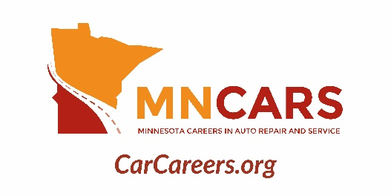
Press Release

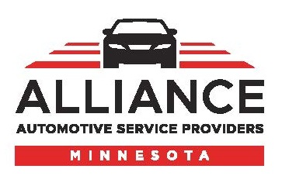
For Immediate Release:
Contact: Judell Anderson, CAE, Executive Director
(612) 623-1110

MNCARS Expands Efforts to Promote Automotive Education & Careers

Minnesota Careers in Auto Repair and Service (MNCARS) is proud to announce the release of new video resources to expand its outreach and raise awareness of career opportunities in the automotive service and collision repair industry.
The new videos feature students who are currently enrolled in automotive programs telling their stories about how they got there and what they love about the industry. These students are the future of the industry and they share their passion and excitement about the opportunities in front of them.
The videos and other updated materials support the 2019 campaign message of “Turn Your Passion into a Career”. In addition to refreshing the campaign’s look and feel and adding text message/SMS marketing capabilities, MNCARS will be advertising on the YouTube platform to reach students with automotive-related interests. The videos will also be utilized on MNCARS’ Instagram and Facebook pages.
To see a few of the student-focused videos, head to the MNCARS YouTube channel. To check out the updated feature video, visit the MNCARS website, www.carcareers.org. While there, click on the MotorMouth icon in the upper right corner to see all of the resources available to help industry members promote these careers in their own communities.
MNCARS is a non-profit organization established in 2016 by the Alliance of Automotive Service Providers of Minnesota (AASP-MN). Its sole purpose is to promote careers in the automotive industry, recruit young people into the state's college-level automotive service and collision repair programs and, ultimately, into industry workplaces. For more information, contact Judell Anderson at 612-623-1110 or judell@aaspmn.org.
###

