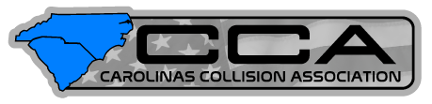

NCACAR & SCACAR Merge
12/10/19 — ON January 1, 2020, North Carolina Association of Collision And Repair and South Carolina Association of Collision And Repair will be merging to form the Carolinas Collision Association, opening up members and sponsors to opportunities that were previously unattainable.

Benefits for Members
Both associations have already independently created relationships with sponsors/speakers/products that have attracted national attention, but with the merger publicly known, more educational opportunities have been made available and attendance has been stronger.

Benefits for Sponsors
With the merger materializing the sponsorship opportunities are reaching a wider audience and allowing for greater opportunities to create relationships. As NCACAR and SCACAR have both made traction and gained momentum in their respective states, the time is perfect to reach an eager audience that is thirsting for knowledge and support.

For more information:
Josh Kent
(704) 998-8553
oregon.josh.kent@gmail.com

For more information on Product:
www.carolinascollisionassociation.com

