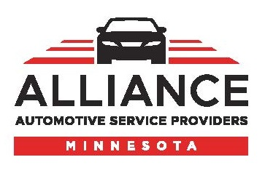
Press Release

For Release: Immediate

Contact: Judell Anderson, CAE, Executive Director
Alliance of Automotive Service Providers of Minnesota (AASP-MN)
(612) 623-1110

AASP-MN Announces 2020 Annual Meeting & Leadership Conference
The Alliance is pleased to announce its Annual Meeting and Leadership Conference will be held April 23, at Delta Hotels by Marriott Minneapolis Northeast. The event, with the theme “Power Up Your Leadership,” offers a line-up of seminars that are tailor made for auto service and collision repair shop owners and managers and presented by some of the industry’s top trainers.

In addition to the impressive agenda of educational programming, there will be ample opportunity for attendees to network and socialize with their peers and industry vendors as they showcase new products and services during happy hour.

Here’s what’s in store:
8:00-9:30AM Opening General Session: Leadership Redefined: Ownership, Engagement, Results! presented by Meridith Powell, MotionFirst
9:45-11:30AM ADAS Presentation and Roundtables
11:30AM-1:30PM Luncheon Keynote: Make Accountability Your Competitive Edge™, presented by Sam Silverstein, Sam Silverstein Enterprises, Inc.
2:00-4:00PM How to Use the Storybrand Framework to Clarify Your Message, presented by Kim Walker, Shop Marketing Pros
2:00-4:00PM Prove it! File Documentation for Profit, presented by Kristen Felder, Collision Hub
2:00-4:00PM Top 8 Front Counter Mistakes & How to Avoid Them, presented by Rick White, 180Biz
4:00-6:00PM Vendors Showcase & Social Hour
For registration information, visit the AASP-MN website, www.aaspmn.org or contact the AASP-MN office at 612-623-1110.

AASP-MN is an association of independently-owned automotive service businesses and industry suppliers dedicated to improving Minnesota’s automotive service industry and the success of its nearly 750 members. For more information, visit www.aaspmn.org.
###

