FOR IMMEDIATE RELEASE
Stacey Wesselink Moellering, I-CAR AVP, Marketing & Segment Development
(847) 463-5293 | stacey.moellering@i-car.com

I-CAR® NAMES JEFF PEEVY TO HEAD NEW ROLE AS VICE PRESIDENT - TECHNICAL PRODUCTS, PROGRAMS & SERVICES

HOFFMAN ESTATES, IL. July 15, 2020 – I-CAR®, the Inter-Industry Conference on Auto Collision Repair, today announced the addition of renowned collision repair industry veteran Jeff Peevy, AMAM, to its executive leadership team as Vice President – Technical Products, Programs & Services.
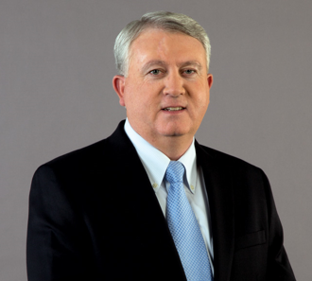
In this new role, which becomes effective at the end of July, Peevy will spearhead the strategic development and growth of all I-CAR curriculum and technical relations efforts while leveraging his more than 20+ years of executive management experience in the industry. Most recently, Peevy served as President of the Automotive Management Institute (AMI) since 2015, and as the 2019-2020 Chairman of the Collision Industry Conference (CIC).
Jeff Peevy, AMAM
He also shares a long and successful history with I-CAR, where he served as senior director of field operations and led I-CAR’s collision repair segment team before his AMI post.
“I couldn’t be more excited to have Jeff - a true industry leader and I-CAR `blue blood’ - return to help lead the future of I-CAR’s curriculum, technical services and technical relations functions amid one of the most dynamic eras of change and opportunity in our industry,” said I-CAR CEO and President John Van Alstyne. “Jeff’s prior experience with the organization, now complemented with five years leading the Automotive Management Institute for the Automotive Service Association (ASA), plus his recent role as CIC chair, prepares him to take this next step in his service to the industry. In doing so, Jeff will help take I-CAR’s offerings and programming to the next level, continuing to build on the solid foundation set with the recent launch of the “Even Better I-CAR” portfolio of program enhancements.”
“I am thrilled to be returning to I-CAR during a time when its mission could not be more important to an industry I respect deeply,” said Jeff Peevy. “I-CAR has made significant important and beneficial progress over the past 5-years, and I’m both humbled and honored to return to work alongside the I-CAR family of professionals who share the same passion for doing the right thing, and that’s squarely fixing cars right. I can’t imagine a more important role that can truly strengthen and benefit our industry in the years to come.”
I-CAR appreciates a strong working relationship with ASA and AMI, and will endeavor to work collaboratively with ASA to affect an orderly transition.
# # #
About I-CAR: Founded in 1979, I-CAR is a not-for-profit education, knowledge and solutions organization designed to support the evolving needs of the Collision Repair Inter-Industry. I-CAR is focused on improving the quality, safety and efficiency of auto collision repair for the ultimate benefit of both the industry and the consumer. www.i-car.com

