Best Practices Using Glue-on Tabs
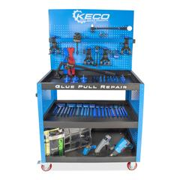
- Move equipment to the vehicle.
- Plug in glue gun and heat gun.
- Determine glue tab(s) that will be used.
- Clean the area with a good wax and grease remover.
- Clean the tab(s) with 90 percent or greater isopropyl alcohol.
- Heat the tab(s) with heat gun (90-100 degrees Fahrenheit).
- Use repair lamp to determine extent of the damage. (Note high and low spots.)
- Clean repair area with 90 percent or stronger isopropyl alcohol.
- Heat panel to 120-140 degrees Fahrenheit with heat gun, and monitor.
- Apply glue to the tab(s) and press into the panel that will be repaired. Use a moderate amount of pressure. Remember to restore body lines first.
- Select the appropriate pulling device.
- Pulling can begin after panel has cooled to 80 degrees Fahrenheit.
- Attach puller (various models to fit) to the tab and pull with a light upward pressure. (Don’t try and pull entire dent at once. Use small incremental steps.)
- Use a slapper or ding hammer to knock down high spots.
- Continue until dent has been removed.
- Apply isopropyl alcohol to the tab to remove.
- Clean up any additional glue with isopropyl alchohol.

