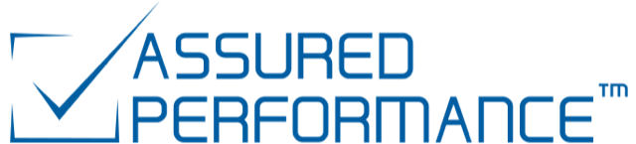
Media Contact:
Liz Stein
(949) 221-0010
FOR IMMEDIATE RELEASE
October 9, 2020
Assured Performance Has Partnered with FCA to Add Premium Italian Manufacturer Alfa Romeo to the Certified Collision Repair Network
Aliso Viejo, CA— Due to the collaborative partnership between FCA and Assured Performance, for the first time ever (as of September 1, 2020) collision repair providers can begin the process of becoming Alfa Romeo Certified. While this certification remains separate from that of FCA, it is made possible due to an exclusive strategic agreement for Assured Performance Network to manage the Alfa Romeo Certified Collision Repair Facility program. This makes Alfa Romeo and FCA integral strategic partners in leveraging the joint-effort collision repair facility certification services, infrastructure, and turnkey programs offered by Assured Performance Certified Collision Care.
This new program allows dealers and independent collision repair facilities to meet the qualifications necessary to be recognized by Assured Performance Collision Care as an Alfa Romeo Certified Collision Repair Facility of choice. It also ensures that Alfa Romeo vehicle owners can choose fully documented certified repairs performed by collision repair providers who have the proper tools, equipment, training, and modified facilities required to repair vehicles to OEM specifications. Customers who visit an Alfa Romeo Certified Repair Facility can also receive a certificate which demonstrates the certified repair they received.
Additional Program Benefits:
- Use of the Alfa Romeo Certified Repair Facility logo and signage.
- The ability to offer Certified Repairs for Alfa Romeo vehicles.
- Access to Assured Performance ShopOps online marketing materials— including social posts, FCA branded images and logos.
- Unlimited use of the new dedicated FCA Technical support team
- Tech Authority repair procedures subscription will be included with certification, effective upon renewal ($1800 value).
- OEM referral version of Body Shop Booster will be included with certification. Discounted pricing on the full version of Body Shop Booster also available.
- Certified shop locators will be available on the Alfa Romeo website, as well as on the Mopar Owner’s Companion App. Collision Assistance is also featured on the app and was the first Collision Assistance Industry app of its kind to promote certified shops!
- Discounted pricing on the wiTECH tool and subscription
- FCA specific courses available through AMI and FCA Certified Shops receive 20% off on all AMi courses.
- Free towing to the nearest certified shop, for vehicles that have been in an accident.
Collision repair providers who meet or surpass the stringent requirements set forth by the Assured Performance Network on behalf of Alfa Romeo and FCA are designated as meeting industry repair requirements for increasingly sophisticated vehicles.
Assured Performance Collision Care is a nonprofit consumer advocacy organization for the Assured Performance Network (www.assuredperformance.net) – the largest and most advanced repair-capable network of 3,500 certified automotive collision repair facilities in North America, with locations throughout the U.S. and Canada and partnerships with the top automobile manufacturers in the industry.

