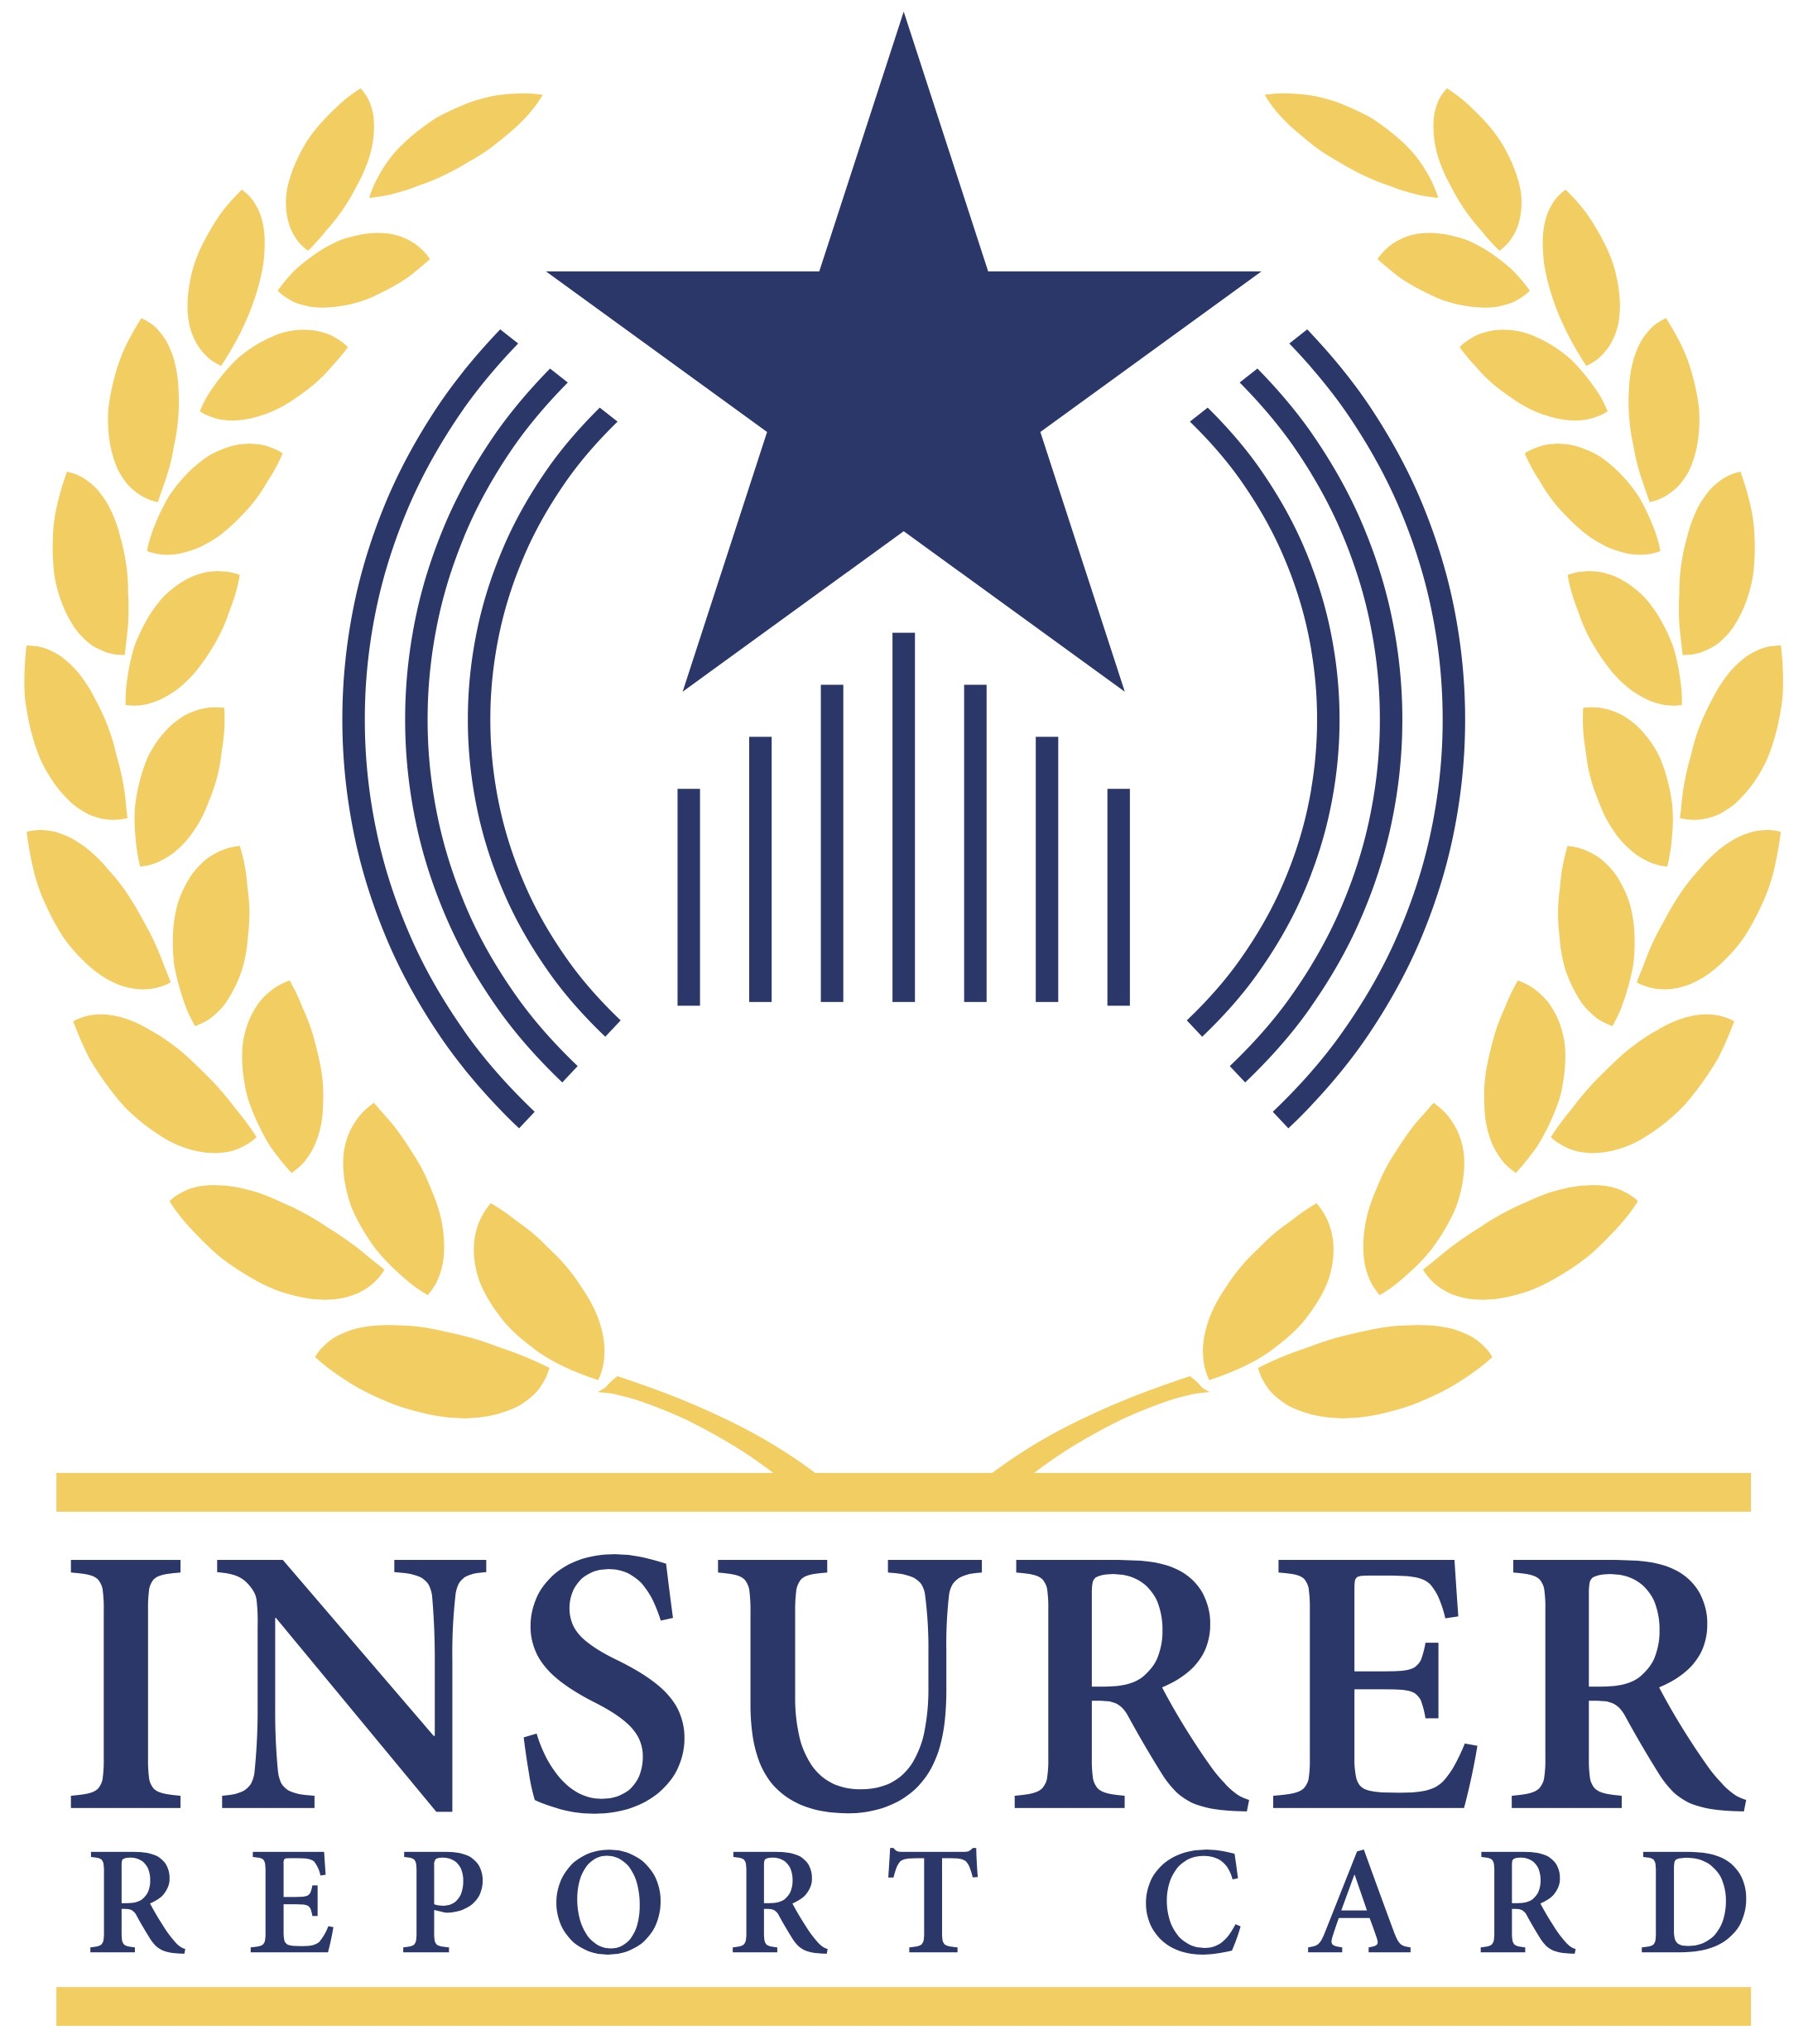

FOR RELEASE: November 3, 2020
FOR MORE INFORMATION: John Yoswick, info@CrashNetwork.com, (503) 335-0393

Help educate consumers by grading the performance of insurers in your state

Collision repair professionals once again have a unique opportunity to grade the performance of the insurance companies in their state, with the launch of CRASH Network’s “Insurer Report Card.”
“Shops interact with insurance companies every day, so they are well aware that not all those insurers are alike,” John Yoswick, the editor of CRASH Network said. “The ‘Insurer Report Card’ is a way for the industry to channel that unique perspective and experience in a way that helps educate consumers. We also see the insurance companies themselves paying attention to this. Some of the highest-graded insurers are using that fact in their marketing. It’s helping them compete for customers against some of the companies that received lower grades from shops, which also gives those lower-ranked companies some incentive to improve.”
The “Insurer Report Card” asks collision repairers to grade each insurer based on how well each carriers' claims practices ensure quality repairs and customer service. By assigning insurers a grade from "A+" to an "F," shops can let consumers know which insurers have their eye on quality repairs and customer service - and which may have some room for improvement - when consumers have a claim.
“Because each state has a different mix of insurers, the ‘Insurer Report Card’ allows repairers to grade insurers specific to their state,” Yoswick said. “As in the past, we’re asking about more than 140 different auto insurance companies across the country, making it far more extensive than any similar surveys, which generally focus on just the 10 largest national insurers. The results of the ‘Insurer Report Card’ can help consumers know, for example, if some smaller or regional insurers they may not be as familiar with are really great at taking care of customers.”
The “Insurer Report Card,” open only to collision repairers, can be completed in less than three minutes (though shops are encouraged to spend some time to explain why they gave each insurer the grade they did), and all individual shop identification information will remain confidential.
Shops that complete the “Insurer Report Card” and provide an e-mail address will be sent the results, at no charge, once they are compiled.
Shops can click here (http://www.CrashNetwork.com/gradebook to grade the insurers.
For more information about the weekly CRASH Network newsletter, visit www.CrashNetwork.com.

