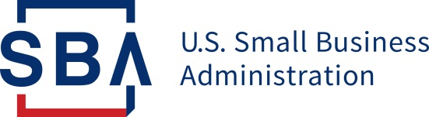
NEWS RELEASE

PRESS OFFICE
Release Date: January 12, 2021 Contact: press_office@sba.gov, www.sba.gov/news
Release Number: 21-06 Follow us on Twitter, Facebook, Blogs & Instagram

1.1 Million Paycheck Protection Program Loans Forgiven So Far
Totaling Over $100 Billion

Small borrowers make up vast majority of forgiveness applicants

WASHINGTON – The U.S. Small Business Administration has already forgiven more than 1.1 million Paycheck Protection Program (PPP) loans for over $100 billion, providing an extraordinary amount of critical relief to America’s small businesses just 3 months since the earliest PPP borrowers’ covered periods ended.

“Today’s news is a key indicator that the PPP is working for all small businesses across our Nation,” said SBA Administrator Jovita Carranza. “For any eligible small business continuing to struggle due to the coronavirus pandemic, the Program has re-opened for new and certain existing PPP borrowers, and we encourage you to take advantage of the PPP to keep your workers on payroll, regardless of any local economic restrictions on your operations. SBA is continuing to work around the clock to forgive existing PPP loans and implement the next phase of this vital Program.”

The SBA has so far received 1,346,125 forgiveness applications for approximately $170.5 billion. SBA has made payment on nearly 85% of the applications, forgiving over $100 billion. For the smallest borrowers with loans up to $50,000, 88% have been approved for forgiveness.

The new data comes as the Paycheck Protection Program has recently re-opened as a result of the Economic Aid to Hard Hit Small Businesses, Nonprofits and Venues Act, signed into law by President Trump on Dec. 27, 2020. The Act added operational expenditures, certain property damage costs, supplier costs and worker protection expenditures, such as drive-through areas, ventilation and sneeze guards, as eligible expenses as well.

The SBA provides PPP Forgiveness Submission & Payment Metrics, as well as Paycheck Protection Program reports, online at www.sba.gov/ppp.

###

About the U.S. Small Business Administration
The U.S. Small Business Administration makes the American dream of business ownership a reality. As the only go-to resource and voice for small businesses backed by the strength of the federal government, the SBA empowers entrepreneurs and small business owners with the resources and support they need to start, grow or expand their businesses, or recover from a declared disaster. It delivers services through an extensive network of SBA field offices and partnerships with public and private organizations. To learn more, visit www.sba.gov.

